

SMART IRRIGATION
MONITORING SYSTEM

A Project Report
Submitted by
BHUVANAN M | 611223114013
ARAVINTH R | 611223114006
AMBIKA B | 611223114003
DHARANESHWARAN B | 611223114020

In partial fulfillment for the award of the degree
of
BACHELOR OF ENGINEERING
in
MECHANICAL ENGINEERING
KNOWLEDGE INSTITUTE OF TECHNOLOGY, SALEM
(An Autonomous Institution)
ANNA UNIVERSITY :: CHENNAI 600 025
FEB 2026
BONAFIDE CERTIFICATE

Certified that this project report “SMART IRRIGATION MONITORING SYSTEM” is the Bonafide work of “BHUVANAN M, ARAVINTH R, AMBIKA B, and DHARANESHWARAN B” who carried out the project work under my supervision.

SIGNATURE SIGNATURE
Dr.K.S. PRABHAKARAN., M.E., PH.D. Prof. A. KAMALAKKANNAN., B.E., M.E.(PhD)
HEAD OF THE DEPARTMENT SUPERVISOR
DEPARTMENT OF ASSISTANT PROFESSOR
MECHANICAL ENGINEERING DEPARTMENT OF
KNOWLEDGE INSTITUTE OF MECHANICAL ENGINEERING
TECHNOLOGY KNOWLEDGE INSTITUTE OF
KIOT CAMPUS TECHNOLOGY, KIOT CAMPUS
KAKAPALAYAM (PO) KAKAPALAYAM (PO)
SALEM – 637504 SALEM-637504

ACKNOWLEDHEMENT

We thank our beloved Executive Chairman and President Dr.PSS.SRINIVASAN, B.E., M.Tech., Ph.D., and all the members of Knowledge Institute of Technology Trust at this high time for providing us with excess of facilities to complete the project successfully.
My heartfelt gratitude to Dr. K. VISAGAVEL, M.E., Ph.D., FIE, Principal of KIOT, for his invaluable guidance and encouragement throughout the journey.
I am very much obliged to Dr. K.S. PRABHAKARAN, M.E., Ph.D., Head of the Department, Mechanical Engineering, for his valuable insights that significantly enhanced the quality of my project.
I am humbled and thankful to Mr. S. SHANMUGAM, M.E., Professor of Practice, Department of Mechanical Engineering, for initiating the Institute to Industry (I2I) course and providing valuable industry exposure. His guidance and motivation greatly enhanced my learning and contributed to the successful completion of my project.
A sincere thanks to my Project Work Supervisor, Mr. A. KAMALAKKANNAN, M.E., Department of Mechanical Engineering, Department of Mechanical Engineering, for his exceptional guidance and unwavering support throughout the project's duration.
I also wish to acknowledge the entire teaching faculty, supporting staffs of the Mechanical Engineering Department, and my fellow students for their assistance and cooperation, which played a vital role in bringing the project to fruition.
I am forever thankful to all who contributed for the successful completion of the project.

ABSTRACT
Water scarcity, climate variability, and inefficient irrigation practices have emerged as critical challenges in the agricultural sector, particularly in regions dependent on traditional farming methods. Conventional irrigation techniques, such as flood and manual irrigation, often result in excessive water usage, uneven distribution, soil degradation, and reduced crop productivity. Additionally, the lack of real-time monitoring and data-driven decision-making leads to poor water management, increased operational costs, and unnecessary human intervention. To address these issues, this project presents an Advanced, Intelligent, Sustainable, and Automated Smart Irrigation Monitoring System aimed at optimizing water utilization and enhancing agricultural efficiency through technology-driven solutions. The proposed system integrates a network of smart sensors, including soil moisture, temperature, and humidity sensors, along with a microcontroller-based control unit and wireless communication module. These components work together to continuously monitor environmental and soil conditions in real time. The collected data is transmitted to a centralized processing unit or cloud-based platform, where it is analyzed using predefined algorithms and decision-making logic. Based on this analysis, the system automatically regulates the operation of irrigation pumps and control valves, ensuring that water is supplied precisely according to crop requirements. This closed-loop feedback control mechanism significantly reduces water wastage, prevents over-irrigation, and promotes efficient resource utilization. A key feature of the system is its automation capability, which minimizes the need for manual intervention and labour-intensive monitoring. Farmers can remotely access real-time data and control irrigation operations through a mobile application or web-based dashboard. This user-friendly interface provides alerts, graphical data visualization, and system status updates, enabling proactive decision-making and improved farm management. The system is also designed to be scalable and adaptable, making it suitable for small-scale farms, large agricultural fields, and greenhouse environments. From a sustainability perspective, the system contributes to responsible water management, conservation of natural resources, and reduction of energy consumption. By optimizing irrigation schedules and minimizing unnecessary water usage, it supports eco-friendly farming practices and aligns with global goals for sustainable agriculture and environmental protection. Furthermore, the intelligent nature of the system allows it to adapt to varying soil types, crop patterns, and climatic conditions, making it highly versatile and practical for real-world applications. In conclusion, the developed Advanced, Intelligent, Sustainable, and Automated Smart Irrigation Monitoring System offers a reliable, cost-effective, and technologically advanced solution for modern agriculture.
TABLE OF CONTENTS
CHAPTER  NO. | CONTENT | PG.NO
 | ABSTRACT | vi
 | LIST OF TABLES | 3
 | LIST OF FIGURES | 4
 | LIST OF SYMBOLS | 5
 | LIST OF ABBREVIATIONS | 6
 | LIST OF NOMENCLATURE | 7
1 | INTRODUCTION | 8
 | 1.1 Methodology
2 | LITERATURE REVIEW | 11
3 | COMPONENTS, SPECIFICATION AND DESCRIPTION | 14
 | 3.1 Components Specification Table
 | 3.2 Components Description | 15
 | 3.2.1 ESP32
 | 3.2.2 Soil Moisture Sensor | 16
 | 3.2.3 Temperature & Humidity Sensor (DHT11) | 17
 | 3.2.4 Relay Module | 18
 | 3.2.5 Water Pump (Motor) | 19
 | 3.2.6 LCD Display | 20
 | 3.2.7 Green LED | 21
 | 3.2.8 Red LED | 22
 | 3.2.9 Connecting Wires | 23
 | 3.2.10 Blynk Platform | 24
 | 3.2.11 Software (Arduino IDE) | 25
4 | WORKING PRINCIPLE | 26
5 | COST ESTIMATION | 29
6 | PROTOTYPE | 30
 | 6.1 3D CAD Modeling | 31
 | RESULTS DOCUMENTATION AND SYSTEM OUTPUTS | 33
 | 6.2 Output Images
 | 6.3 System Performance Observation
 | 6.4 Result Tables | 34
7 | SCOPE OF FUTURE WORK | 35
 | 7.1 Advantages
 | 7.2 Applications
8 | APPENDICES | 36
 | Appendix – 1: Field Visit
 | Appendix – 2: Components Specification | 38
 | Appendix – 3: Pseudo Code for Key Functions | 40
9 | CONCLUSION | 45
 | REFERENCES | 46

LIST OF TABLES

TABLE NO. | TITLE | PAGE.NO.
TABLE 3.1 | List of components in scaled experimental prototype | 14
TABLE 3.2 | List of components in full – scaled residential. | 15
TABLE 5.1 | Cost Estimation | 29

LIST OF FIGURES
FIGURE NO | TITLE | PAGE NO
Figure 3.1 | ESP32 | 15
Figure 3.2 | Soil Moisture Sensor | 16
Figure 3.3 | Temperature & Humidity Sensor | 17
Figure 3.4 | Relay Module | 18
Figure 3.5 | Water Pump (Motor) | 19
Figure 3.6 | LCD Display | 20
Figure 3.7 | Green LED | 21
Figure 3.8 | Red LED | 22
Figure 3.9 | Connecting Wires | 23
Figure 3.10 | Blynk Platform | 24
Figure 3.11 | Software (Arduino IDE) | 25
Figure 4.1 | Flowchart of Working Principle | 28
Figure 6.12 | Isometric View (3D CAD Model) | 31
Figure 6.13 | Top View (3D CAD Model)
Figure 6.14 | Front View (3D CAD Model) | 32

LIST OF SYMOLS
SYMBOL | DESCRIPTION
V | Voltage (Volts)
A | Current (Amperes)
W | Power (Watts)
Ω | Resistance (Ohms)
°C | Temperature (Degrees Celsius)
% | Percentage (Humidity / Moisture Level)
MHz | Megahertz (Processor Clock Speed)
MB | Megabytes (Flash Memory)
L/min | Litres per Minute (Flow Rate)
DC | Direct Current
AC | Alternating Current

LIST OF ABBREVIATIONS

ABBREVIATION | FULL FORM
IoT | Internet of Things
ESP32 | Espressis Systems Microcontroller 32-bit
DHT11 | Digital Humidity and Temperature Sensor
LCD | Liquid Crystal Display
LED | Light Emitting Diode
GPIO | General Purpose Input Output
ADC | Analog to Digital Converter
I2C | Inter-Integrated Circuit
SPI | Serial Peripheral Interface
UART | Universal Asynchronous Receiver Transmitter
Wi-Fi | Wireless Fidelity
GSM | Global System for Mobile Communication
IDE | Integrated Development Environment
PCB | Printed Circuit Board
CAD | Computer Aided Design

LIST OF NOMENCLATURE

TERM | DESCRIPTION
Soil Moisture | Amount of water content present in the soil
Threshold Value | Predefined limit used for irrigation decision-making
Relay Module | Electrically controlled switch for pump operation
Microcontroller | Embedded processor unit (ESP32) controlling the system
Blynk Platform | IoT cloud platform for remote monitoring via mobile app
Closed-Loop Control | Automatic feedback-based control mechanism
Sensor Node | Device that senses and transmits environmental data
Prototype | Physical working model of the proposed system
Automation | Operation of system without manual intervention
Remote Monitoring | Monitoring system status from a distant location

CHAPTER 1

INTRODUCTION

Agriculture is the backbone of the economy and a primary source of livelihood for a large portion of the global population. The growth and productivity of crops are heavily dependent on the availability and proper management of water. However, rapid population growth, urbanization, industrial expansion, and climate change have significantly increased the demand for freshwater resources. As a result, water scarcity has become one of the most critical challenges faced by the agricultural sector today. In many regions, farmers rely on traditional irrigation methods such as flood irrigation, drip irrigation without automation, or manual watering, which often lead to inefficient water usage and resource wastage.
Conventional irrigation techniques lack precision and do not consider real-time soil and environmental conditions. Farmers usually irrigate their fields based on experience or fixed schedules rather than actual crop requirements. This practice results in over-irrigation in some areas and under-irrigation in others, leading to poor soil health, nutrient leaching, waterlogging, and reduced crop yield. Additionally, manual irrigation requires continuous human effort, time, and labor, making it inefficient and costly, especially for large agricultural lands.
To address these limitations, modern agriculture is gradually shifting toward smart and technology-driven solutions. The concept of smart irrigation integrates sensors, automation, and data analytics to create an efficient and sustainable water management system. In this context, this project proposes the development of an Advanced, Intelligent, Sustainable, and Automated Smart Irrigation Monitoring System that utilizes Internet of Things (IoT) and embedded systems technology to monitor and control irrigation processes in real time. The proposed system consists of soil moisture sensors, temperature and humidity sensors, a microcontroller-based control unit, and a wireless communication module. These components work together to continuously collect and analyse environmental and soil data from the field. Based on predefined threshold values and intelligent decision-making algorithms, the system automatically activates or deactivates irrigation pumps and valves as required. This closed-loop feedback control mechanism ensures precise water delivery, minimizes wastage, and maintains optimal soil conditions for plant growth.
Furthermore, the system allows remote monitoring and control through a mobile application or web-based dashboard, enabling farmers to access real-time field data from anywhere. Alerts and notifications can be sent to the user in case of abnormal conditions, such as extremely low soil moisture or pump failure. This feature enhances reliability, convenience, and overall farm management efficiency.
Overall, the proposed smart irrigation monitoring system aims to revolutionize traditional farming practices by promoting precision agriculture, conserving water resources, reducing manual labor, and improving crop productivity. It represents a significant step toward sustainable agriculture and smart farming, making irrigation more efficient, cost-effective, and environmentally responsible.

1.1 METHODOLOGY
mart Irrigation Monitoring System involves a systematic approach that integrates hardware design, sensor data acquisition, data processing, automation control, and remote monitoring. The implementation is carried out in several stages to ensure accuracy, reliability, and efficiency of the system.
In the first stage, a detailed study of existing irrigation methods and smart irrigation technologies is conducted to identify their limitations and define the requirements of the proposed system. Based on this analysis, suitable sensors, microcontrollers, and communication modules are selected for system development.
In the second stage, the hardware components, including soil moisture sensor, temperature and humidity sensor, microcontroller (such as Arduino or ESP32), relay module, water pump, and power supply, are assembled and interconnected. The sensors are placed in the soil at appropriate depths to accurately measure soil moisture and environmental conditions.
In the third stage, the microcontroller is programmed using embedded C or Arduino IDE to read sensor data continuously. Threshold values for soil moisture are predefined based on crop and soil type. The microcontroller processes the data and makes intelligent decisions to control the irrigation pump automatically through a relay switch.
In the fourth stage, a wireless communication module (such as Wi-Fi or GSM) is integrated into the system to enable data transmission to a cloud platform or mobile application. This allows real-time monitoring of soil conditions and system status from a remote location.
In the final stage, the system is tested under different environmental and soil conditions to evaluate its performance, accuracy, and reliability. Necessary modifications are made based on test results to optimize system efficiency.
Overall, the adopted methodology ensures the successful design, implementation, and validation of an automated, intelligent, and sustainable smart irrigation monitoring system for modern agricultural applications.

CHAPTER 2

LITERATURE REVIEW
The development of smart irrigation systems has attracted significant attention from researchers due to increasing water scarcity, inefficient traditional irrigation practices, and the need for precision agriculture. Various studies have explored the use of sensors, automation, IoT, and data-driven decision-making to optimize water usage in agriculture. The following section presents a survey of relevant literature in the field of smart irrigation monitoring systems.
Kim et al. (2008)
Kim and his team developed an automated irrigation system based on soil moisture sensors and wireless sensor networks. The study demonstrated that real-time monitoring of soil moisture levels could significantly reduce water consumption while maintaining optimal soil conditions for crop growth. The results showed a reduction in water usage by nearly 25% compared to conventional irrigation methods.
Zhang et al. (2010)
The authors proposed an IoT-based smart irrigation system that integrates soil moisture, temperature, and humidity sensors with a wireless communication module. Their system allowed remote monitoring and control of irrigation through a mobile application. The study concluded that IoT-enabled irrigation systems enhance water efficiency and reduce manual labour in agricultural operations.
Bhuvaneswari et al. (2012)
This research focused on the use of microcontroller-based automated irrigation systems using soil moisture sensors. The system automatically turned ON and OFF the water pump based on predefined moisture threshold levels. The results indicated that automation reduces water wastage and ensures uniform water distribution across agricultural fields.
Patil and Thorat (2014)
Patil and Thorat designed a GSM-based smart irrigation system that sends real-time alerts to farmers regarding soil moisture levels and pump status. The study highlighted that mobile-based notification systems improve decision-making and enable timely irrigation management, especially in rural areas.
Srinivasan et al. (2016)
The authors developed a cloud-based smart irrigation monitoring system using IoT technology. Sensor data collected from the field was transmitted to a cloud server for analysis and visualization. The study demonstrated that cloud-based platforms provide better data storage, accessibility, and scalability for large agricultural applications
Kumar and Singh (2017)
This study investigated the integration of weather forecasting data with smart irrigation systems. By considering rainfall predictions and environmental conditions, the system optimized irrigation scheduling and avoided unnecessary watering. The results showed improved water conservation and better crop yield.
Jain et al. (2018)
Jain and his team implemented a machine learning-based smart irrigation system that predicts irrigation requirements based on historical data and real-time sensor inputs. The study concluded that AI-driven systems provide more accurate irrigation control but require higher computational resources and infrastructure.
Reddy et al. (2020)
The researchers proposed a low-cost IoT-based smart irrigation system for small-scale farmers. The system used affordable sensors and microcontrollers, making it accessible and practical for rural agricultural communities. The study emphasized that cost-effective smart irrigation solutions can significantly improve water management in developing countries.
Summary of Literature Review
The reviewed studies indicate that smart irrigation systems using sensors, automation, and IoT technologies have proven effective in reducing water wastage, improving crop productivity, and minimizing human intervention. However, challenges such as high cost, dependence on internet connectivity, system complexity, and maintenance requirements still exist. These limitations highlight the need for a simple, reliable, and cost-effective Advanced, Intelligent, Sustainable, and Automated Smart Irrigation Monitoring System, which is the focus of this project.

S.No | Component | Specification
1 | ESP32 Wi-Fi Module | 3.3V/5V, Dual-core, Inbuilt Wi-Fi
2 | Soil Moisture Sensor | Analog output, 3.3V/5V
3 | Temperature & Humidity Sensor (DHT11/DHT22) | Digital output, 3.3V/5V
4 | Relay Module | 5V, 10A
5 | Water Pump (Motor) | 12V DC, 3–5 L/min
6 | LCD Display (16×2 / I2C) | 5V
7 | Green LED | 2–3V
8 | Red LED | 2–3V
9 | Power Supply | 12V Adapter / Battery
10 | Connecting Wires | Jumper wires
11 | Blynk Platform | Web/Mobile App
12 | Software | Arduino IDE

CHAPTER 3

COMPONENTS SPECIFICATION AND DESCRIPTION

3.1 COMPONENTS SPECIFICATION TABLE
3.1 components specification
3.2 COMPONENTS DESCRIPTION

3.2.1 ESP 32
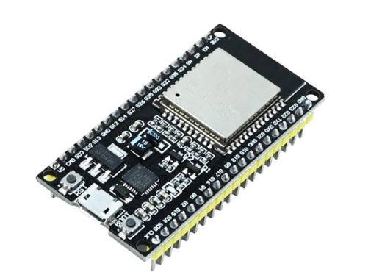
Figure 3.1 ESP32
The ESP32 is a low-cost, low-power, high-performance microcontroller with built-in Wi-Fi and Bluetooth capabilities, developed by Expressive Systems. It is widely used in Internet of Things (IoT) and automation applications due to its strong processing power, wireless communication, and multiple interfacing options. These features make it highly suitable for smart systems such as the Smart Irrigation Monitoring System.
The ESP32 is based on a dual-core Tensilica Xtensa LX6 processor operating at up to 240 MHz, which enables fast and efficient data processing. It supports low-power operation, making it suitable for battery-powered applications. The microcontroller also contains sufficient memory to handle sensor data, control logic, and wireless communication simultaneously.
One of the major advantages of the ESP32 is its integrated Wi-Fi (802.11 b/g/n) and Bluetooth, which allows real-time data transmission to cloud platforms and mobile applications such as Blynk or Thing Speak. In the proposed irrigation system, the ESP32 collects data from soil moisture and DHT11 sensors, processes it, and sends it to a mobile application for remote monitoring.
The ESP32 has multiple GPIO pins, ADC inputs, and communication interfaces like I2C, SPI, and UART, enabling easy connection with sensors, relay modules, LEDs, and display units. It can be programmed using the Arduino IDE, which makes it simple and user-friendly for students and researchers.

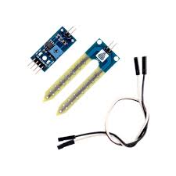
3.2.2 Soil Moisture Sensor
Figure 3.2 Soil moisture sensor

A soil moisture sensor is an essential component of the Smart Irrigation Monitoring System, used to measure the water content present in the soil. It helps in determining whether the soil is sufficiently wet or dry, allowing the system to make automated irrigation decisions. The sensor operates based on the principle of electrical conductivity between two probes inserted into the soil.
The sensor consists of two metal probes and a sensor module. When the soil contains more water, it becomes more conductive, resulting in a lower resistance and a higher sensor output value. Conversely, when the soil is dry, its resistance increases, leading to a lower output signal. This analog signal is sent to the ESP32 microcontroller for processing.
In the proposed system, the soil moisture sensor continuously monitors the moisture level and provides real-time data to the ESP32. Based on predefined threshold values, the microcontroller decides whether to turn the water pump ON or OFF through the relay module. If the moisture level is low, the pump is activated, and the red LED turns ON. If the moisture level is sufficient, the pump remains OFF, and the green LED turns ON.
The soil moisture sensor is easy to interface, cost-effective, and suitable for agricultural applications. It plays a crucial role in reducing water wastage, improving irrigation efficiency, and ensuring healthy crop growth through automated monitoring and control.

3.2.3 Temperature & Humidity Sensor (DHT11)
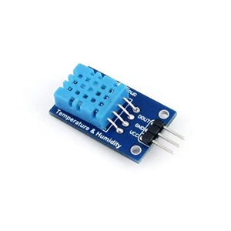

Figure 3.3 Temperature & Humidity Sensor
The Temperature and Humidity Sensor (DHT11/DHT22) is an important component in the Smart Irrigation Monitoring System used to measure the surrounding environmental conditions. This sensor provides digital readings of ambient temperature and relative humidity, which are useful for understanding climatic conditions affecting soil moisture and crop health.
The DHT11 sensor is a low-cost sensor with moderate accuracy, suitable for basic applications, while the DHT22 offers higher accuracy and a wider measurement range, making it more suitable for precise monitoring. Both sensors operate at 3.3V or 5V and communicate with the ESP32 microcontroller through a single digital data pin.
In the proposed system, the sensor continuously collects temperature and humidity data and sends it to the ESP32. The microcontroller processes this information and displays it on the LCD screen as well as uploads it to the Blynk web platform for real-time remote monitoring on a mobile phone.

3.2.4 Relay Module
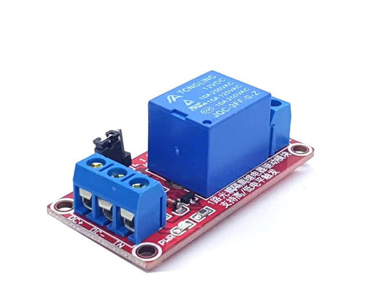

Figure 3.4 Relay Module
The relay module is a crucial component in the Smart Irrigation Monitoring System, used to control the ON/OFF operation of the water pump safely and effectively. Since the ESP32 operates at low voltage and current levels, it cannot directly drive a high-power device like a motor or pump. Therefore, the relay module acts as an electrically controlled switch between the low-voltage control circuit and the high-voltage pump circuit.
The relay module consists of an electromagnetic relay, a driver transistor, a diode for protection against back electromotive force (EMF), and an LED indicator for status visualization. When the ESP32 sends a HIGH or LOW signal to the relay input pin, the internal coil of the relay gets energized or de-energized accordingly. This action opens or closes the relay contacts, turning the water pump ON or OFF.
In the proposed system, when the soil moisture level falls below the predefined threshold, the ESP32 activates the relay module, which switches ON the water pump to supply water to the plants. Simultaneously, the red LED turns ON and the green LED turns OFF, indicating low moisture condition. When sufficient moisture is detected, the relay turns OFF the pump, the green LED turns ON, and the red LED turns OFF.

3.2.5 Water Pump (Motor)
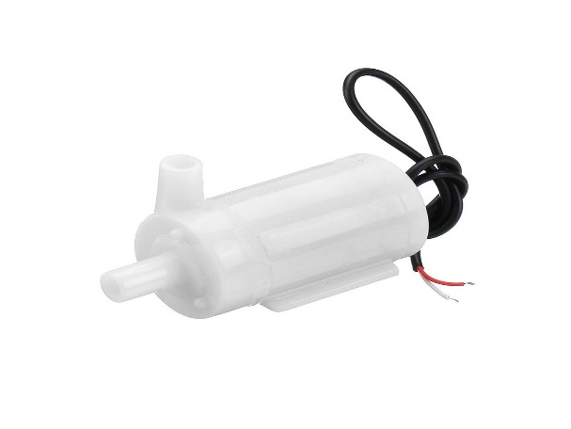

Figure 3.5 Water Pump (Motor)
The water pump (motor) is a key actuator component in the Smart Irrigation Monitoring System, responsible for supplying water to the crops when irrigation is required. It is a 12V DC submersible or surface pump that draws water from a tank, reservoir, or water source and delivers it through pipes or drip lines to the agricultural field.
The pump operates based on control signals from the ESP32 through the relay module. Since the ESP32 cannot directly power the motor due to its low voltage and current limitations, the relay module acts as an intermediary switch to control the pump safely. When the relay is activated, the pump receives power from the external power supply and starts pumping water. When the relay is deactivated, the pump stops automatically.
In the proposed system, when the soil moisture sensor detects low moisture levels, the ESP32 sends a signal to the relay module, which turns ON the pump to irrigate the soil. At the same time, the red LED turns ON to indicate that watering is in progress. Once the desired moisture level is reached, the ESP32 turns OFF the relay, stopping the pump, and the green LED turns ON to indicate adequate moisture.
The water pump is energy-efficient, reliable, and suitable for small-scale and medium-scale irrigation systems. It plays a vital role in automating water distribution, reducing manual effort, and ensuring efficient water management in smart agriculture applications.

3.2.6 LCD Display
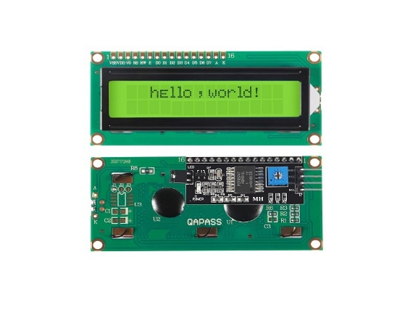

Figure 3.6 LCD Display
The 16×2 LCD display with I2C interface is used in the Smart Irrigation Monitoring System to visually display real-time sensor data and system status. The display consists of 16 columns and 2 rows, allowing it to show up to 32 characters at a time. It provides a simple and effective user interface for monitoring temperature, humidity, soil moisture level, and motor status without the need for a mobile phone or computer.
The I2C module reduces the number of required connections between the ESP32 and the LCD. Instead of using multiple data pins, it only requires two communication lines: SDA (data) and SCL (clock), along with power supply (VCC) and ground (GND). This simplifies wiring, saves GPIO pins on the ESP32, and makes the circuit more compact and organized.
In the proposed system, the LCD continuously displays the temperature, humidity, soil moisture percentage, and whether the motor is ON or OFF. For example, it may show messages like “Temp: 32°C”, “Humidity: 60%”, “Moisture: LOW”, and “Motor: ON”. This allows users to easily understand the system condition at a glance.
The LCD display enhances user interaction, improves system readability, and provides immediate feedback on irrigation performance. It is a reliable, low-power, and cost-effective component that plays an important role in the overall functionality of the smart irrigation system.

3.2.7 Green LED
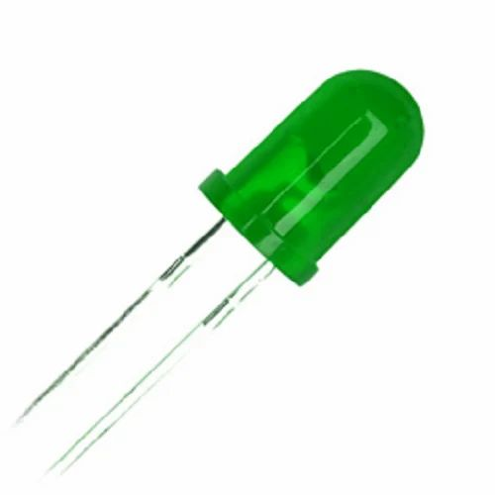

Figure 3.7 Green LED
The Green LED is used as a visual indicator in the Smart Irrigation Monitoring System to represent a safe or adequate soil moisture condition. It provides an immediate and easily understandable status signal without requiring users to check the display or mobile application.
The Green LED is connected to a digital output pin of the ESP32 through a current-limiting resistor to prevent damage from excess current. When the ESP32 detects that the soil moisture level is above the predefined threshold (i.e., sufficient water content in the soil), it sends a HIGH signal to the Green LED, turning it ON.
In this condition, the relay remains OFF, the water pump does not operate, and the Green LED glows continuously to indicate that irrigation is not required. When the soil moisture level drops below the threshold, the Green LED automatically turns OFF, and the Red LED turns ON along with the motor.
The Green LED improves system usability by providing a clear, real-time visual indication of soil condition, making the system more user-friendly and effective for farmers and users.

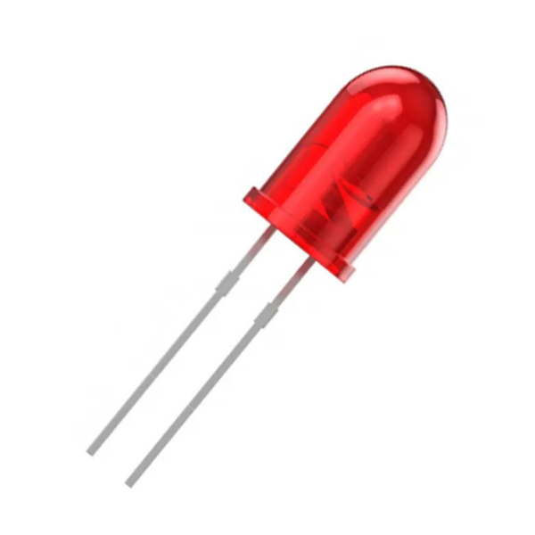
3.2.8 Red LED

Figure 3.8 Red LED
The Red LED is used as a visual indicator in the Smart Irrigation Monitoring System to represent a low soil moisture or irrigation-required condition. It provides a clear and immediate warning signal to the user that the soil is dry and watering is in progress.
The Red LED is connected to a digital output pin of the ESP32 through a current-limiting resistor to protect it from excessive current. When the ESP32 detects that the soil moisture level is below the predefined threshold, it sends a HIGH signal to the Red LED, turning it ON.
In this condition, the relay module is activated, which switches ON the water pump to supply water to the soil. Simultaneously, the Green LED turns OFF, indicating that the soil is not in a safe moisture range. Once the soil reaches the required moisture level, the Red LED turns OFF, and the Green LED turns ON automatically.
The Red LED enhances the system’s usability by providing a simple and intuitive visual alert, helping users quickly understand when irrigation is needed without checking the display or mobile application.

3.2.9 Connecting Wires
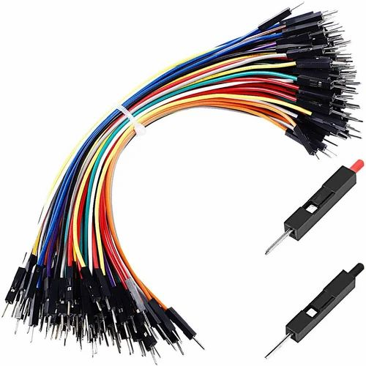

Figure 3.9 Connecting Wires
Connecting wires (jumper wires) are used in the Smart Irrigation Monitoring System to establish electrical connections between all components, including the ESP32, sensors, relay module, LCD display, LEDs, and power supply. These wires ensure proper signal transmission and power distribution throughout the circuit.
The system primarily uses male-to-male, male-to-female, and female-to-female jumper wires, depending on the type of connection required between the ESP32 and other components. For stable and secure connections, breadboard or soldered wiring can be used based on the prototype or final model design.
Proper wiring is essential to avoid loose connections, signal loss, or short circuits. The wires are arranged neatly to maintain circuit clarity, reduce interference, and improve system reliability. In the proposed setup, separate power and signal wires are used to minimize electrical noise and ensure accurate sensor readings.
Overall, connecting wires play a fundamental role in integrating all components into a functional smart irrigation system, enabling seamless communication and efficient operation.

3.2.10 Blynk Platform
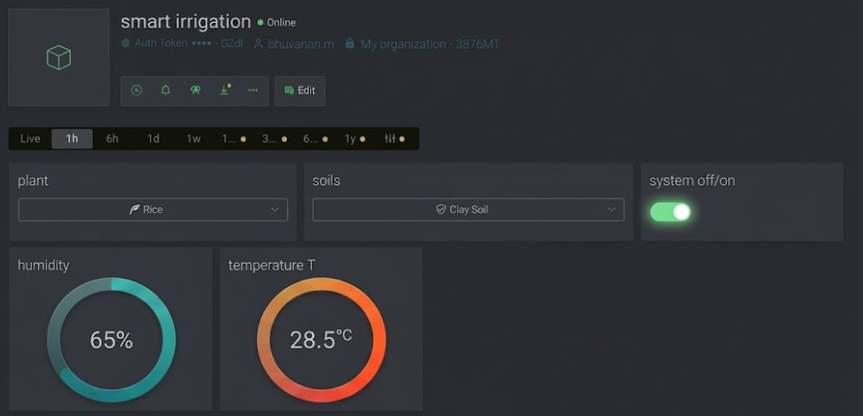

Figure 3.10 Blynk Platform
Blynk is an Internet of Things (IoT) cloud platform used in the Smart Irrigation Monitoring System for real-time monitoring and control through a mobile application or web dashboard. It provides an easy-to-use interface that allows users to visualize sensor data and remotely manage the irrigation system from anywhere with internet connectivity.
In the proposed system, the ESP32 is connected to the Blynk platform via Wi-Fi. It continuously sends data such as soil moisture level, temperature, humidity, and motor status to the Blynk server. This data is displayed in the form of numerical values, gauges, or graphs on the user’s mobile phone or web interface.
Blynk also enables remote control of the system. Users can manually turn the water pump ON or OFF using virtual buttons in the Blynk application if required. Additionally, alerts or notifications can be configured to inform users when soil moisture is low or when the pump is activated.
The Blynk platform enhances system flexibility, accessibility, and automation by enabling real-time data monitoring and remote irrigation control. It plays a crucial role in making the smart irrigation system more intelligent, user-friendly, and efficient for modern agricultural applications.

3.2.11 Software
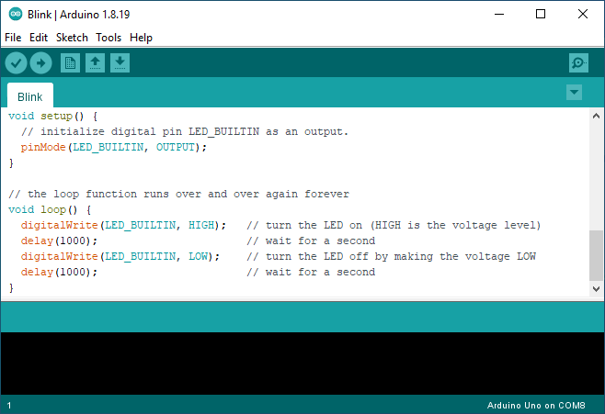

Figure 3.11 Software
The software plays a vital role in the Smart Irrigation Monitoring System by controlling data acquisition, decision-making, and communication between hardware components and the Blynk platform. The system is programmed using the Arduino IDE, which provides a simple and user-friendly environment for coding the ESP32.
The software continuously reads data from the soil moisture sensor and the DHT11 temperature and humidity sensor. Based on predefined threshold values, the program decides whether to turn the water pump ON or OFF through the relay module. It also controls the Green and Red LEDs to indicate soil moisture status and updates the LCD display with real-time sensor readings.
Additionally, the software enables Wi-Fi connectivity of the ESP32 and sends sensor data to the Blynk cloud platform for remote monitoring via mobile or web. The program also allows manual control of the motor through the Blynk application if needed.
Overall, the software integrates all system components, ensuring automation, real-time monitoring, and efficient irrigation management.

CHAPTER 4
WORKING PRINCIPLE
The Smart Irrigation Monitoring System is designed to optimize water usage in agriculture by automating the irrigation process based on real-time environmental and soil conditions. The system integrates sensors, a microcontroller, a water pump, and a cloud-based monitoring platform to create an efficient, reliable, and user-friendly irrigation mechanism. The primary objective of the system is to ensure that crops receive adequate water only when required, thereby preventing water wastage and improving agricultural productivity.
The working principle of the system is based on continuous monitoring of soil moisture, temperature, and humidity using appropriate sensors. These sensors are interfaced with a microcontroller (such as Arduino or ESP32), which acts as the central processing unit of the system. The soil moisture sensor is inserted into the soil at the root level of the plants to measure the water content present in the soil. It operates on the principle of electrical resistance or capacitance, where the moisture level in the soil affects the sensor’s output voltage. When the soil is dry, the resistance is high, resulting in a higher sensor reading. Conversely, when the soil is wet, the resistance decreases, producing a lower sensor reading.
Along with soil moisture sensing, a temperature and humidity sensor (such as DHT11 or DHT22) is used to monitor the surrounding environmental conditions. This helps in understanding the climatic factors that influence soil dryness and plant water requirements. The sensor continuously collects data and sends it to the microcontroller in the form of digital or analog signals.
The microcontroller processes the incoming data using a pre-programmed algorithm. A predefined threshold value for soil moisture is stored in the system. If the measured soil moisture level falls below this threshold, the microcontroller interprets that the soil is dry and initiates the irrigation process. It sends a control signal to a relay module, which acts as an electronic switch to turn ON the water pump (motor). The pump then supplies water to the field through a network of pipes or drip irrigation emitters.
Once the soil moisture level reaches or exceeds the desired threshold, the microcontroller automatically turns OFF the pump by deactivating the relay. This closed-loop feedback mechanism ensures that water is supplied only when necessary, reducing manual intervention and conserving water resources. The entire process is automatic and does not require continuous human monitoring.
To enhance user interaction and monitoring, the system is integrated with an LCD display and the Blynk IoT platform. The LCD display provides real-time information such as soil moisture level, temperature, humidity, and pump status. This allows farmers or users to visually monitor the system’s operation at the site. Additionally, the Blynk application enables remote monitoring and control through a smartphone or computer. The sensor data is transmitted to the cloud via Wi-Fi (using ESP32 or ESP8266), allowing users to check soil conditions from anywhere in the world.
The system also includes visual indicators such as a Green LED and Red LED. The Green LED indicates that the soil has sufficient moisture and the pump is OFF, while the Red LED indicates that the soil is dry and the pump is ON. This provides a simple and intuitive visual feedback mechanism.
In summary, the working principle of the Smart Irrigation Monitoring System is based on real-time data acquisition, intelligent decision-making, and automated control. By integrating sensors, microcontroller, relay, pump, and IoT connectivity, the system ensures efficient water management, reduces labor, prevents over-irrigation, and promotes sustainable agriculture. This technology is particularly beneficial in regions facing water scarcity and can significantly improve crop yield and resource utilization.
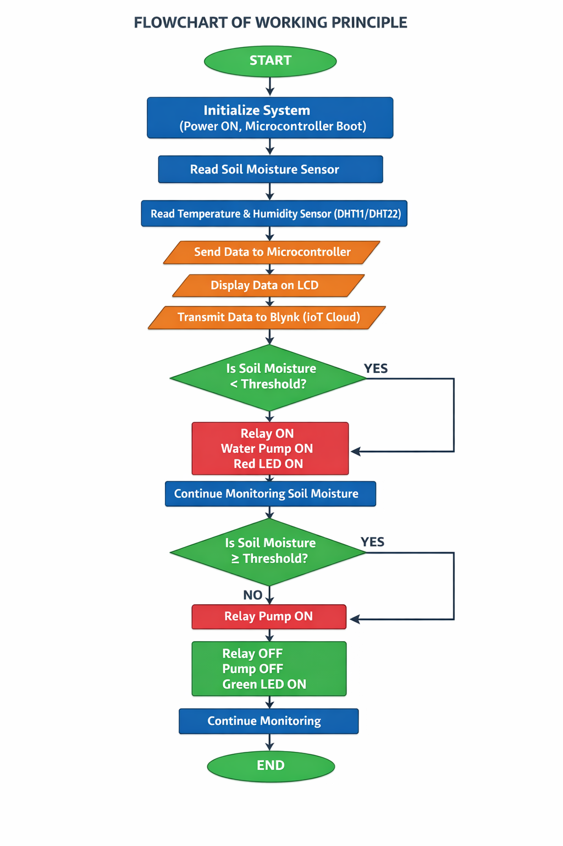
Figure 4.1 Flow Chart

CHAPTER 5
COST ESTIMATION
S.NO | Component Name | Specification | Quantity | Approx. Cost (₹)
1 | Microcontroller | ESP32 (Wi-Fi & Bluetooth) | 1 | 900
2 | Soil Moisture Sensor | Resistive type (low-cost) | 1 | 200
3 | Temperature & Humidity Sensor | DHT11 | 1 | 120
4 | Relay Module | 5V Single Channel | 1 | 100
5 | Water Pump (DC Motor) | Mini 12V Pump | 1 | 300
6 | LCD Display | 16×2 with I2C | 1 | 300
7 | Power Supply | 12V Adapter | 1 | 250
8 | Green LED | Indicator | 1 | 10
9 | Red LED | Indicator | 1 | 10
10 | Connecting Wires | Jumper wires (set) | 1 | 120
11 | Pipes & Drip Tubes | Small irrigation setup | As required | 150
12 | Enclosure Box | Project casing | 1 | 120
13 | Blynk (IoT Platform) | Software | 1 | 0 (Free)
Total |  |  |  | 1480
5.1 Cost Estimation
CHAPTER 6
PROTOTYPE

A physical prototype was developed to demonstrate and validate the proposed Smart Irrigation Monitoring System under controlled conditions. The prototype represents a simplified working model of an automated irrigation setup incorporating soil moisture sensing, microcontroller-based decision making, and IoT-based remote monitoring features. The objective of this prototype is concept validation and system performance evaluation rather than large-scale field deployment. The prototype consists of an ESP32 microcontroller mounted on a breadboard, interfaced with a soil moisture sensor inserted into a soil sample container, and connected to a relay-controlled water pump. The sensor continuously measures soil moisture levels and transmits the data to the microcontroller for real-time processing.
When the soil moisture level falls below the predefined threshold, the microcontroller automatically activates the relay module, which switches ON the water pump to supply water. Simultaneously, the Red LED turns ON indicating irrigation in progress. Once adequate moisture is detected, the pump is turned OFF and the Green LED glows, confirming sufficient soil moisture. All sensor readings including temperature, humidity, soil moisture, and motor status are displayed on the 16×2 LCD screen and transmitted to the Blynk IoT platform for remote monitoring through a smartphone application.

6.1 3D Cad Modeling
Isometric view
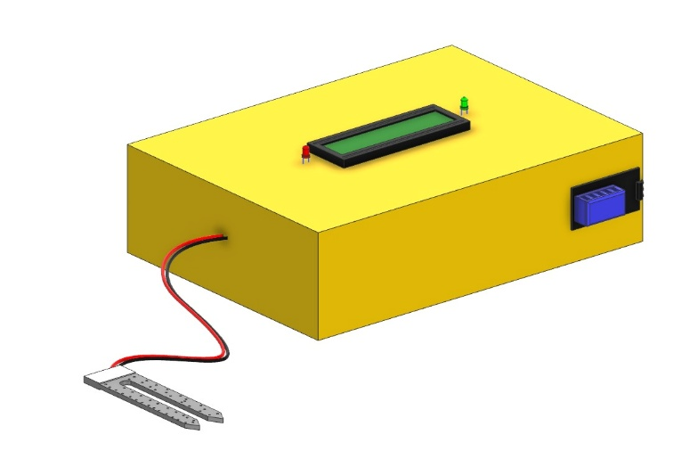

Figure 6.12 Isometric view
Top view
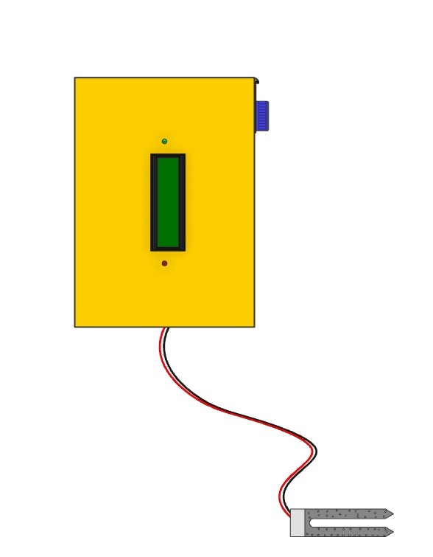
Figure 6.13 top view

Front view
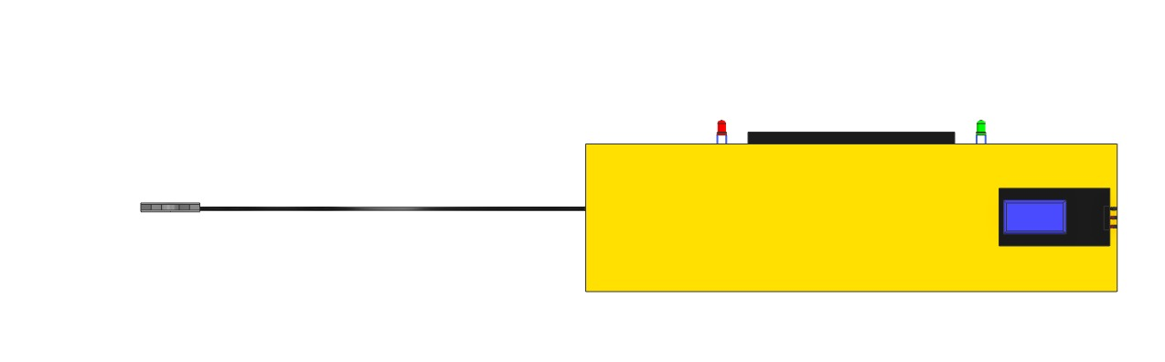

Figure 6.14 front view

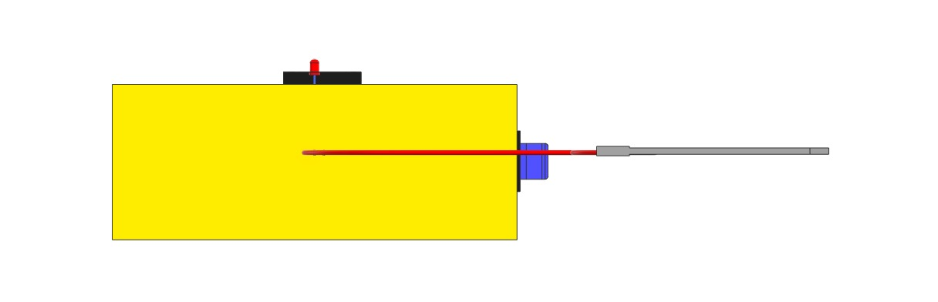
Right Side view

Figure 6.15 right side view

RESULTS DOCUMENTATION AND SYSTEM OUTPUTS
6.2 Output Images
Output images represent the visual results obtained during the testing and operation of the Smart Irrigation Monitoring System. These images provide evidence of system performance and demonstrate the real-time working of hardware and software components. The images include sensor readings, pump operation status, LCD display outputs, and IoT monitoring results from the Blynk application. These outputs help to verify the accuracy and efficiency of the system.
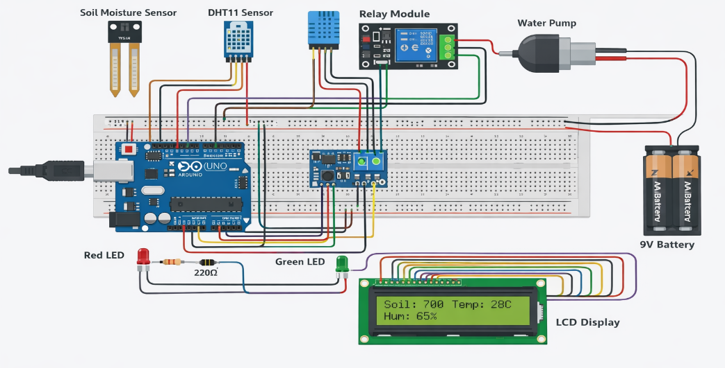

Figure 6.2 Simulation Model
- Hardware setup of the project
- LCD display showing moisture, temperature, humidity
- Pump ON condition (dry soil test)
- Pump OFF condition (wet soil test)
- Blynk mobile app output screen
- Soil moisture sensor testing images
6.3 System Performance Observation
This section explains the observations made during system testing under different environmental and soil conditions. The system was tested by placing the soil moisture sensor in dry and wet soil samples. It was observed that when the soil moisture level dropped below the threshold value, the ESP32 microcontroller activated the relay and turned ON the water pump automatically. When sufficient moisture was detected, the pump was turned OFF, ensuring proper irrigation control.
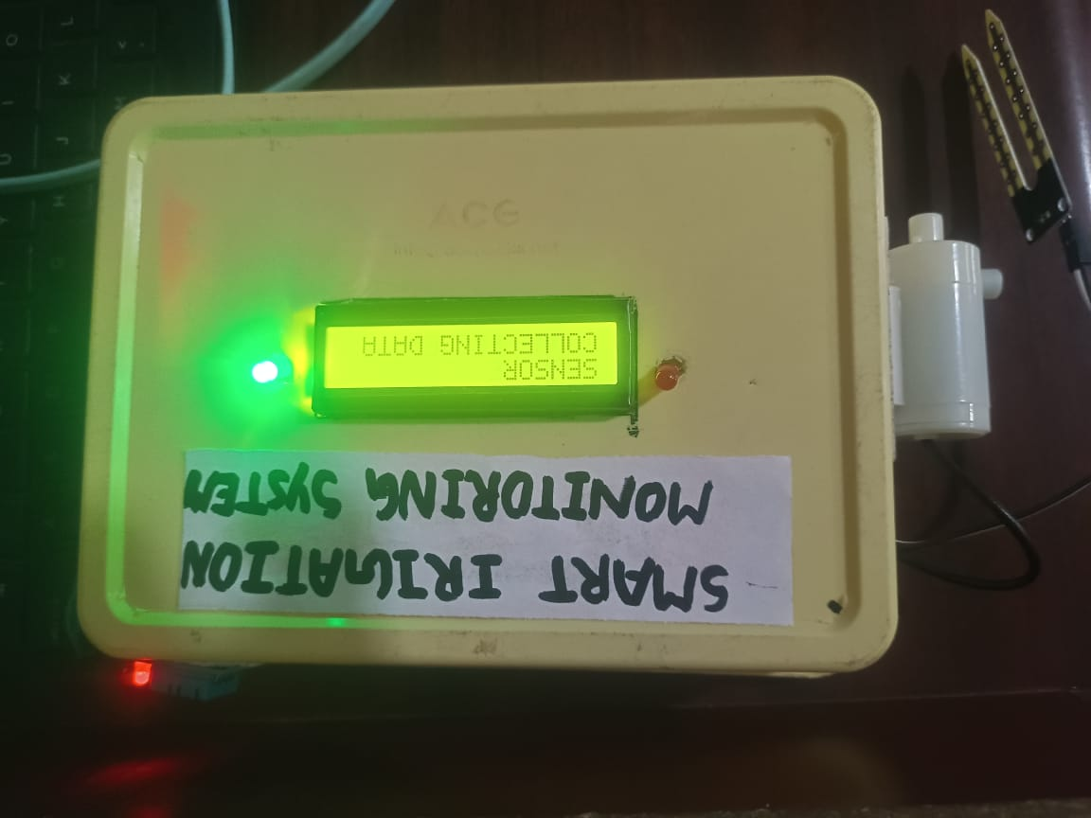

Figure 6.3 Testing and Observation Results
The system continuously monitored temperature and humidity levels and displayed real-time values on the LCD and Blynk IoT platform. The response time of the system was quick, and sensor readings were stable and accurate. The system successfully reduced water wastage and minimized manual monitoring.
- Sensor accuracy observation
- Pump response time
- IoT data monitoring performance
- Water saving efficiency
- Stability of system operation
6.4 Result Tables
The results tables present the experimental readings obtained during system testing. These tables show the relationship between soil moisture levels and pump operation. The results confirm that the irrigation system functions automatically based on real-time soil conditions.

CHAPTER 7
SCOPE OF WORK
SCOPE OF FUTURE WORK
- Integration of advanced sensors such as pH sensors, nutrient sensors, and rain sensors for better soil and environmental monitoring.
- Implementation of weather forecasting integration to improve irrigation scheduling.
- Development of wireless sensor networks for monitoring large agricultural fields.
- Expansion of the system to support multiple crop monitoring and automatic irrigation customization.
- Improvement in sensor durability by replacing resistive sensors with capacitive moisture sensors.
- Integration of automatic fertilizer supply system along with irrigation control.

ADVANTAGES
- Reduces water wastage by automatic irrigation control.
- Minimizes manual labour and human effort.
- Improves crop growth by maintaining proper soil moisture.
- Provides real-time monitoring using IoT technology.
- Enables remote monitoring and control through mobile applications.
- Promotes water conservation and sustainable agriculture.

APPLICATIONS
- Agricultural fields for automatic irrigation.
- Greenhouses and polyhouse farming.
- Home gardens and smart gardening systems.
- Nurseries and plant cultivation centres.
- Landscaping and lawn irrigation.
CHAPTER 8
APPENDICES
APPENDIX – 1
FIELD VISIT
As part of the Smart Irrigation Monitoring System project, a field visit was conducted to study the existing irrigation practices and understand real-time agricultural challenges. The visit was carried out in a nearby agricultural farm where traditional irrigation methods such as manual watering and motor-based pumping were being used. During the visit, observations were made regarding water usage, soil conditions, crop type, and farmer involvement in irrigation management.
It was observed that irrigation was mainly performed manually or based on fixed time intervals without considering the actual soil moisture condition. This often resulted in overwatering or underwatering, leading to water wastage and uneven crop growth. The farmers also faced difficulties in continuously monitoring soil conditions, especially during hot climatic conditions. Additionally, electricity consumption for water pumps was found to be higher due to the absence of automatic control mechanisms.
Based on these observations, the need for an automated irrigation monitoring system was clearly identified. The Smart Irrigation Monitoring System was designed to address these challenges by incorporating soil moisture sensors, environmental monitoring, and IoT-based remote control using ESP32. The system ensures that water is supplied only when required, thereby conserving water, reducing manual labour, and improving crop productivity.
The field visit helped in understanding practical issues faced in agriculture and provided valuable insights for designing an efficient and user-friendly irrigation solution. It also confirmed the feasibility and real-world applicability of the proposed system.

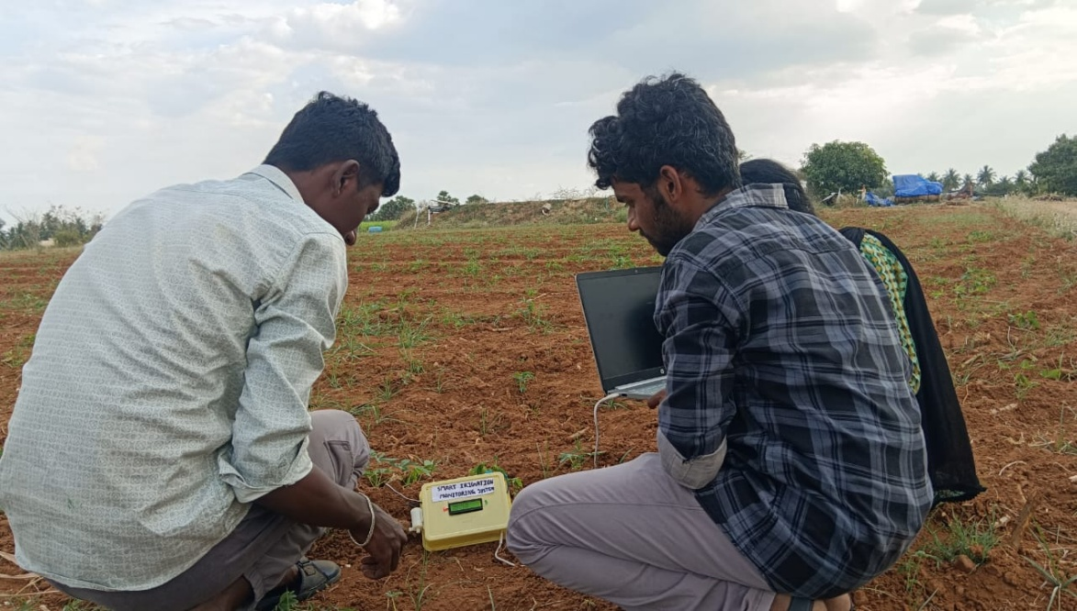

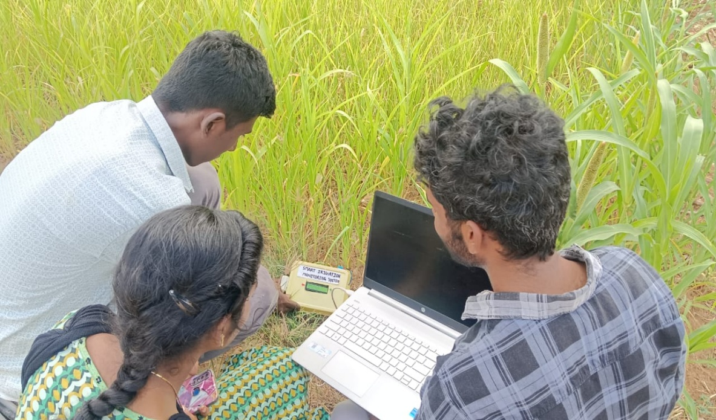

Figure 8.1 Field Visit

APPENDIX – 2
COMPONENTS SPECIFICATION
PROTOTYPE SPECIFICATION
1. ESP32 Microcontroller
- Operating Voltage: 3.3V
- Input Voltage (Recommended): 5V–12V
- Wi-Fi: 802.11 b/g/n
- Bluetooth: v4.2 (BLE + Classic)
- CPU: Dual-core 32-bit processor
- Clock Speed: Up to 240 MHz
- Digital I/O Pins: 30+
- Analog Input Pins: 12-bit ADC
- Flash Memory: 4MB
- Communication Protocols: UART, SPI, I2C
2. Soil Moisture Sensor
- Operating Voltage: 3.3V – 5V
- Output Type: Analog & Digital
- Measuring Range: 0–100% moisture level
- Material: Corrosion-prone metal probes
3. DHT11 Temperature & Humidity Sensor
- Operating Voltage: 3V – 5V
- Temperature Range: 0°C to 50°C
- Temperature Accuracy: ±2°C
- Humidity Range: 20% – 90% RH
- Humidity Accuracy: ±5%
- Output: Digital Signal
4. Relay Module
- Operating Voltage: 5V
- Trigger Voltage: 3.3V/5V compatible
- Type: Electromechanical relay
- Load Capacity:
- 10A at 250V AC
- 10A at 30V DC

5. 12V DC Water Pump
- Operating Voltage: 12V DC
- Current Consumption: 0.5A – 1A
- Power Rating: 6W – 12W
- Flow Rate: 2–5 liters/min
- Type: Submersible mini pump
6. LCD Display
- Operating Voltage: 5V
- Display Type: Alphanumeric
- Characters: 16 characters × 2 lines
- Communication: I2C protocol
- I2C Address: 0x27
7. LEDs (Red & Green)
- Operating Voltage: 2V – 3V
- Current: 20Ma
- Red LED → Pump ON indicator
- Green LED → Pump OFF indicator
8. Connecting Wires
- Type: Male-to-Male / Male-to-Female
- Length: 10–20 cm
- Used for breadboard connections

APPENDIX – 3
PSEUDO CODE FOR KEY FUNCTIONS
Pseudo Code 1: System Initialization Function
START System Initialization
Initialize serial communication

Configure RELAY_PIN as OUTPUT
Configure RED_LED as OUTPUT
Configure GREEN_LED as OUTPUT

Set RELAY_PIN to OFF
Set RED_LED to OFF
Set GREEN_LED to ON

Initialize I2C communication
Initialize LCD display
Turn LCD backlight ON

Initialize DHT temperature and humidity sensor

Display "WELCOME" on LCD
Display "TEAM AEROLEAF"
Wait for 2 seconds

Clear LCD

Display "SENSOR"
Display "COLLECTING DATA"
Wait for 2 seconds

END System Initialization

Pseudo Code 2: Soil Moisture Reading Function
START Read_Soil_Moisture

Read analog value from SOIL_PIN
Store value in soil Value variable

RETURN soil Value

END Read_Soil_Moisture

Pseudo Code 3: Temperature and Humidity Reading Function
START Read_Temperature_Humidity

Read humidity from DHT sensor
Read temperature from DHT sensor

IF humidity OR temperature is invalid
Set humidity = 0
Set temperature = 0
END IF

RETURN temperature, humidity

END Read_Temperature_Humidity

Pseudo Code 4: Irrigation Control Function
START Irrigation Control

IF soilValue > soilDry AND temperature > tempLimit AND humidity < humLimit

Turn RELAY ON
Turn RED_LED ON
Turn GREEN_LED OFF
motorState = ON

ELSE

Turn RELAY OFF
Turn RED_LED OFF
Turn GREEN_LED ON
motorState = OFF

END IF

RETURN motorState

END Irrigation_Control

Pseudo Code 5: LCD Display Function
START Display_Data

Clear LCD

Display temperature on first row
Display humidity on first row

Display soil moisture value on second row

IF motorState = ON
Display "ON"
ELSE
Display "OFF"
END IF
END Display_Data

Pseudo Code 6: Main Monitoring Loop
START Main_Loop

WHILE system is running

soilValue = Read_Soil_Moisture()

temperature, humidity = Read_Temperature_Humidity()

motorState = Irrigation_Control()

Display_Data()

Wait for 2.5 seconds

END WHILE

END Main_Loop

CHAPTER 10
CONCLUSION
The Smart Irrigation Monitoring System was successfully designed and implemented using an ESP32 microcontroller, soil moisture sensor, DHT11 temperature and humidity sensor, relay module, and IoT-based monitoring through the Blynk platform. The primary objective of this project was to develop an automated irrigation system that efficiently manages water usage based on real-time soil and environmental conditions.
The developed prototype effectively monitors soil moisture levels and automatically controls the water pump when the moisture level falls below a predefined threshold. This ensures that crops receive adequate water without over-irrigation or wastage. The integration of Wi-Fi connectivity enables remote monitoring and control through a smartphone application, making the system more convenient and user-friendly.
During testing, the system demonstrated accurate sensor readings, quick response time, and reliable pump operation. The automatic cut-off mechanism successfully prevented excessive water supply, thereby conserving water and reducing manual effort. The system is suitable for small-scale agricultural fields, gardens, and greenhouse applications.
Overall, the Smart Irrigation Monitoring System provides a cost-effective, efficient, and sustainable solution for modern agriculture. It reduces water consumption, minimizes labor requirements, and promotes smart farming practices. With further enhancements such as additional sensors and large-scale implementation, the system can significantly contribute to improved agricultural productivity and resource management.

REFERENCES
- K. Dwivedi, A. Misra, and S. Kumar, “IoT Based Smart Irrigation System Using ESP32,” Int. J. Adv. Res. Comput. Sci. Softw. Eng., vol. 9, no. 7, Jul. 2023.
- R. Singh and P. Verma, “Automated Irrigation System using Soil Moisture Sensor and Blynk IoT Platform,” J. Agric. Eng., vol. 12, no. 2, 2022.
- S. Sharma and M. Gupta, “Design and Implementation of Smart Irrigation System Using ESP32 and Sensors,” IEEE Int. Conf. Sustainable Technol., 2021.
- H. Patel and D. Joshi, “Wireless Sensor Based Irrigation Control System,” Int. J. Eng. Technol., vol. 8, no. 4, 2020.
- A. Kumar and S. Reddy, “Review on Smart Irrigation Techniques and IoT Water Conservation,” Int. J. Future Rev. Compute. Sci. Commun. Eng., 2023.
- L. Zhang, “IoT Based Smart Agriculture with Machine Learning and Sensor Data,” J. Intel. Sys., vol. 15, no. 3, 2022.
- M. Li and J. Wang, “Cloud-Assisted Precision Irrigation Using IoT Sensors,” IEEE Access, vol. 7, pp. 67954–67965, 2019.
- R. Verma and T. Singh, “Real-Time Soil Moisture Monitoring System for Irrigation,” Int. J. Smart Sens. Intel. Syst., 2021.
- J. Park et al., “Energy Efficient Wireless Sensor Networks for Smart Agriculture,” IEEE Sensors J., vol. 19, no. 14, 2019.
- S. A. Saleem and F. Ahmad, “Automated Drip Irrigation System using Arduino,” Int. J. Soft Comput. Eng., vol. 7, no. 3, 2020.
- DHT11 Sensor Datasheet, Ansong Electronics, 2018. Available: https://cdn.sparkfun.com/datasheets/Sensors/Temperature/DHT11.pdf
- ESP32 Technical Reference Manual, Espressos Systems. Available: https://www.espressif.com/sites/default/files/documentation/esp32_technical_reference_manual_en.pdf
- Soil Moisture Sensor Datasheet, Maker Lab Components, 2019. Available: https://components.makerlab.org/soil-moisture-sensor-datasheet.pdf
- “Blynk IoT Platform – Quick Start Guide,” Blynk Documentation, 2024. Available: https://docs.blynk.io/
- S. K. Jain and V. Gupta, “IoT Applications in Precision Farming,” Int. J. Innov. Res. Sci. Eng. Technol., 2022.
- M. A. Khan and Z. Islam, “Smart Agriculture Using Wireless Sensor Networks,” Int. J. Comput. Appl., vol. 174, no. 4, 2021.
- T. A. Rahman et al., “Cloud Computing Framework for Smart Farming,” J. Agric. Inform., vol. 10, no. 1, 2023.
- A. Sharma and R. Bhatia, “Comparison of Soil Moisture Sensor Technologies,” Int. J. Eng. Technol., 2020.
- P. K. Singh et al., “Performance Evaluation of IoT Sensor Nodes in Agriculture,” J. Wirel. Mob. Netw., vol. 13, no. 2, 2021.
- J. Lee and Y. Hong, “Wireless Network Design for Smart Agriculture,” IEEE Trans. Ind. Inform., vol. 15, no. 6, 2020.
- L. Atzori, A. Iera, and G. Morabito, “The Internet of Things: A Survey,” Computer Networks, vol. 54, no. 15, pp. 2787–2805, Oct. 2010.
- M. Hassan, M. A. Razzaque, and C. Al Faruque, “Data Analytics in IoT: A Survey,” IEEE Int. Conf. on Big Data, 2018.
- S. R. Biradar and P. N. Pore, “IoT-Based Smart Agriculture: Sensors, Architecture and Challenges,” Int. J. Innov. Sci. Eng. Technol., vol. 7, no. 1, 2020.
- D. L. Nguyen, M. Ding, and B. Gill, “Wireless Sensor Network Solutions for Precision Irrigation,” IEEE Intl. Wireless Symp., 2018.
- N. Javaid et al., “Applications of Wireless Sensor Networks for Water Monitoring Systems in Agriculture,” Sensors, vol. 19, no. 19, 2019.
- R. J. F. Rosillo, “ESP32 Wi-Fi and Bluetooth Integration for Smart Applications,” Int. J. Smart Appl., 2021.
- B. T. Pham and T. T. Nguyen, “Design of Intelligent Irrigation System Using IoT Technology,” Int. J. Comp. Netw. Comm., vol. 11, no. 4, 2020.
- S. K. Sharma and X. Wang, “Live Data Enabled Smart Irrigation Using Cloud Computing,” Int. J. Cloud Appl. Comput., 2022.
- A. Charania, “Smart Farming with Low-Cost IoT Sensors,” Agricultural Eng. Journal, vol. 6, no. 2, 2021.
- M. Majumder, “Cloud-Centric Precision Agriculture: Review and Future Trends,” IEEE Access, vol. 7, 2019.
- S. Ahamed and R. Ali, “Automated Irrigation Management using IoT,” International Conf. on Emerging Trends in Comput., 2021.
- J. Misra and S. Das, “Sensors and Actuators for Smart Farming,” Automation in Agric. Systems, 2020.
- T. N. Nguyen and H. Q. Bui, “Performance Analysis of Soil Moisture Sensor Types,” J. Sens. Technol., vol. 10, pp. 55–72, 2021.
- R. M. Kumar and K. Balaraman, “Smart Irrigation Using Wireless Communication Modules,” Int. J. Wirel. Tech. Res., 2020.
- M. F. Ahmed and M. J. Akhtar, “Smart Farming with IoT Sensor Networks and Cloud Backend,” Int. J. Comp. Sci. Mob. Comput., 2019.
- M. H. A. Wahab and N. A. Rahim, “Cloud-based Irrigation Control for Precision Farming,” IEEE Future Tech Conf., 2020.
- P. K. Mishra, “Integration of IoT with Traditional Agriculture: Benefits and Challenges,” Int. J. Agric. Eng. Res., 2022.
- M. R. Islam, “Sensor Network Optimization Techniques for Smart Farming,” IEEE Trans. Sustain. Comput., 2019.
- S. Singh and R. Gautam, “Smart Irrigation using LoRaWAN Technology for Farm Automation,” J. IoT and Smart Technol., 2021.
- D. Dahiya and S. Kumar, “Machine Learning based Irrigation Forecasting,” Int. J. Innov. AI and Tech., 2023.
- B. Roy and A. Tripathi, “Overview of Soil Moisture Sensing Technologies,” Int. J. Sens. Systems, 2021.
- J. Wang et al., “Advanced IoT Platforms for Smart Farm Management,” IEEE Cloud Comp., vol. 8, no. 4, 2022.
- A. Alle et al., “Comparative Study of ESP32, Arduino, and Raspberry Pi for IoT Projects,” Int. J. Smart Sys. Design, 2020.
- H. Kim and D. Kim, “Low-Power IoT Architectures for Sensing Applications,” IEEE Sensors Conf., 2019.
- P. Dharashive and M. Sawale, “Smart Irrigation System Techniques Using Artificial Intelligence and IoT,” International Journal of Intelligent Systems and Applications in Engineering, 2023.
- B. C. Babu, P. Venu, V. R. Kumar, Y. Jhansi, and K. Geethanjali, “Design and Development of an IoT Based Smart Irrigation System in Agriculture Fields,” International Journal of Innovative Science and Research Technology, vol. 10, no. 4, 2025.
- J. Gutierrez et al., “IoT-Based Smart Irrigation Systems: An Overview on Recent Trends,” Sensors Journal, vol. 20, no. 4, 2020.
- H. Shahab, M. Naeem, and M. Iqbal, “IoT-Driven Smart Agricultural Technology for Soil and Crop Optimization,” Smart Agricultural Technology Journal, 2025.
- K. Sharma and S. Shivandu, “Integrating Artificial Intelligence and IoT for Crop Monitoring in Precision Agriculture,” Sensors International, 2024.
- S. Roy, S. Misra, and S. K. Das, “AgriSens: IoT-Based Dynamic Irrigation Scheduling System,” IEEE Internet of Things Journal, vol. 8, no. 6, 2020.
- X. Feng et al., “Smart Irrigation System for Sustainable Agriculture Using IoT Monitoring,” Electronics Journal, 2024.
- A. Hasib and A. S. M. A. Sarkar, “IoT-Based Smart Plant Monitoring and Irrigation System with Real-Time Environmental Sensing,” arXiv Research Paper, 2026.
- K. Taueatsoala et al., “TinyML Enabled IoT Framework for Sustainable Precision Irrigation,” arXiv Research Publication, 2026.
- Y. E. Kunt, “Development of a Smart Autonomous Irrigation System Using IoT and Artificial Intelligence,” arXiv Research Publication, 2025.

